Model Factors That Affecting Mastery of Statistics Subject on Psychology Students of at Universitas Padjadjaran University of Padjadjaran

RATNA JATNIKA
FITRI ARIYANTI ABIDIN

Universitas Padjadjaran University of Padjadjaran
Model Factors that Affect Mastery of Statistics on Psychology Students at
University of Padjadjaran

ABSTRACT

Purpose – This research is a causal study to obtain a model of the influence of cognitive and non-cognitive factors, which affect the mastery of statistics subject in psychology students of Universitas Padjadjaran

Method – The cognitive factor studied is mathematically thinking skill. The non-cognitive factor studied is attitude toward statistics and anxiety toward statistics. Mastery of statistics subject is done by taking the final score of Statictics 2. The sample of this research are college students in the Faculty of Psychology at Universitas Padjadjaran year 2013. The data processing is done using path analysis.

Result – The result of research shows that mathematically thinking skill positively influences the mastery of statistics subject. Aspect of affect, cognitive competence, value and difficulty negatively influences anxiety factor, fearful behavior, hopes or demands, history, and self-concept. Effort aspect positively influences students’ attitude toward statistics and negatively influences hopes or demands. Anxiety factor toward statistics that influences scores that represent the mastery of statistics subject, is only fearful behavior factor.
Keywords : mathematically thinking skill, student’ attitude toward statistics, anxiety toward statistics, mastery of statistics subject

INTRODUCTION

The importance of statistics as a tool for analyzing data and drawing conclusion as well as the basis for other subjects such as Psychometric, Construction Test, Experimental Psychology, Research Methodology, and Thesis; basically been conceived and realized by the college students. However, that understanding and awareness is not enough yet to encourage students in mastering statistics. The data supporting this is, besides the final scores is not satisfactory, the students also seen trouble using the statistics on applied subject, for example, Advanced Experimental Psychology. The “reluctance” for using statistics and appraisal that statistics is difficult, is clear from the observations on behavior of students, for example, when they review the use of statistics in Advanced Experimental Psychology.

Our previous studies focused on the attitudes of students in statistics. This is based on the reference which stated that "attitude" plays an important role in social psychology. Ajzen (1989) revealed a global definition of the attitudes, namely; "Attitude is the disposition of the individual to respond positively or negatively to various aspects that can be separated from the world of the individual". In this case, the "world" associated as statistics. The lectures and students of statistics convinced that attitudes toward statistics are important. Students who feel and express a negative attitude can create an uncomfortable classroom atmosphere (Gal, Ginsburg & Schau). Attitudes affect the achievement and the use of statistics in life outside the classroom.

However, the research we have done states that there is no relationship between attitudes of students in statistics with the achievement of score which is a statistical representation of mastery of statistic. Effort of changing the statistics curriculum into practical use method also has no effect on student attitudes toward statistics (Jatnika and Abidin, .....). Thus, due to the efforts of increasing student mastery of statistics is important to be continued, it needs to be explored other factors than the attitude of students towards statistics.

According to the reference, there are two major factors that will influence to the mastery of statistics, which are the factors associated with cognitive and non-cognitive factors, that is more psychological. Those factors will be explored, as the basis for preparing programs that are both academic and non-academic to improve student mastery of statistics.

Problem Identification
On one side of hand, statistics is importat to be mastered by students and graduates of the Faculty of Psychology. On the other hand, mastery of statistics still does not meet the learning objectives have been set. The existence of this gap makes us feel important to do the research about;
- What are the factors that influence the mastery of statistics on Psychology student’ of Universitas Padjadjaran?
- How is the contribution of each of these factors to mastery of statistics on Psychology student’ of Universitas Padjadjaran?

Purpose and Benefit of the Research
The purpose of this research is to collect data for:
- Identify what are the factors that influence the mastery of statistics on Psychology student’ of Universitas Padjadjaran
- To construct a model of contribution from each factors on mastery of statistics on Psychology student’ of Universitas Padjadjaran

METHOD

Research Methods and Experimental Design
This research is a causal study to obtain a model of the influence of cognitive factor and non-cognitive factors on the mastery of statistics in psychology students of Universitas Padjadjaran.

Conceptual Definitions and Operational Definitions
Cognitive factor
The cognitive factor is learning skill of students, related to the way of receiving and processing information in learning process (Lee, et al, 2002). The cognitive factor studied is mathematically thinking skill.
Non-cognitive factor
Non-cognitive factor is the things outside of student’s learning skill, related to the psychology and enviromentally factors (Lee, et al, 2002). The cognitive factor studied is attitude toward statistic and anxiety toward statistic.
Mastery of Statistic
The mastery of statistic is done by taking the student’s final score of Statistic 2.
Research Instruments and Data Collection Techniques

Mathematically thinking skill measured by aspect of RA (…..) from IST (…..).

Attitude toward statistic measured by SATS (Student Attitude toward Statistics) which is developed by Schau (2003). SATS consist of aspects :
1. Affect
2. Cognitive competence
3. Value
4. Difficulty
5. Interest
6. Effort
- Anxiety toward Statistics measured by SAM (Statistics Anxiety Measure) which is developed by Benson and Clark (1982) and DeVellis (2003). SAM consist of aspects:
1. Anxiety Factor
2. Fearfull Behaviour Factor
3. Attitude Factor
4. Expectation Factor
5. History & Self-Concept Factor
6. Performance Factor
- The mastery of statistics by taking from final score of Statistics 2, which is a combination of midterms score, final exam score, quizzes and assignments.

Population, Characteristics of Sample, and Research Sample
The population of this research are college students in Faculty of Psychology at Universitas Padjadjaran year 2013 that have characteristics as follows:
1. Already took Statistics 1 course
2. Already took Statistics 2 course
The sample of this research are the total sampling that match with the characteristics had been determined.
Processing and Analyzing Data
1. Trial phase on the instruments to know Psychometric Properties from the instrument that was done by calculate the reliability and validity of the instruments.
2. Testing the hypothesis was done by using path analysis to obtain a model of the influence of cognitive factor and non-cognitive factors on the mastery of Statistics on college students of Faculty of Psychology at Universitas Padjadjaran.

RESULTS

Measuring Instruments Trial Stage

Attitude toward Statistics Measuring Instrument Trial
Table 1
Result of SATS Measuring Instrument’s Reliability

ASPECT | ALPHA CRONBACH (n = 81)
AFFECT | 0.844
COGNITIVE | 0.766
VALUE | 0.716
DIFFICULTY | 0.400
INTEREST | 0.828
EFFORT | 0.783

SATS
AFFECT
COGNITIVE
VALUE
DIFFICULTY
INTEREST
EFFORT
0.85
0.70
0.46
0.79
0.73
0.47
0.27
0.38
0.52
0.78
0.47
0.78

Goodness of Fit Index = 0.89; Root Mean Square Error of Approximation (RMSEA) = 0.017; Chi-Square = 9.26 (P = 0.32)

Picture 1.Result of SATS Measuring Instrument’s Confirmatory Factors Analysis

Based on the result from table 1 and picture 1, it can be seen that SATS measuring instrument is reliable and valid.

Anxiety about Statistics Measuring Instrument Trial

Table 2
Result of SAM Measuring Instrument’s Reliability

ASPECT | ALPHA CRONBACH (n= 125)
Anxiety Factor | 0.882
Fearfull Behaviour Factor | 0.825
Attitude Factor | 0.784
Expectation Factor | 0.723
History & Self-Concept Factor | 0.862
Performance Factor | 0.870

SAM
ANXIETY FACTOR
FEARFULL
BEHAVIOR
ATTITUDE
EXPECTATION
HISTORY &SELF CONCEPT
PERFORMANCE
0.55
0.63
0.54
0.72
0.81
-0.51
0.70
0.49
0.60
0.71
0.24
0.74

Goodness of Fit Index = 0.929; Root Mean Square Error of Approximation (RMSEA) = 0.151; Chi-Square = 33.08 (P = 0.00013)

Picture 2. Result of SAM Measuring Instrument’s Confirmatory Factor Analysis

Based on the result from Picture 2, it is shown that there is an aspect that does not have any meaning which is performance. If this construct factor is used to measure students’ self-perception on how good they are in statistics compared to their friends, the meaninglessness of this factor is probably caused by the students are not used to facing a problem where they have to compare themselves to their peers. The difficulty of comparing themselves to their peers can also be caused by not having data about their peers’ scores and achievements which can be objective materials to compare themselves to their peers. That is why performance aspect is removed from SAM measuring instrument. The obtained results are:

SAM
ANXIETY FACTOR
FEARFULL
BEHAVIOR
ATTITUDE
EXPECTATION
HISTORY &SELF CONCEPT
PERFORMANCE
0.52
0.64
0.54
0.68
0.85
0.72
0.54
0.59
0.71
0.29

Goodness of Fit Index = 0.931; Root Mean Square Error of Approximation (RMSEA) = 0.196; Chi-Square = 27.50 (P = 0.0005)

Picture 3. Confirmatory Factors Analysis after Performance Aspect is removed

Result of Research Data
The result of data processing:
Table 3
Result Track for SATS influences on SAM (Anxiety) with Backward Method
Aspects |  |  | Standardized Coefficients |  |  | t | P
 |  |  | Beta |  |  | t | P
 | AFFECT |  | -.177 |  |  | -1.716 | .090
 | COGNITIVE |  | -.397 |  |  | -3.849 | .000

Table 4
Result Track for SATS Influences on SAM (Fearful Behavior) with Backward Method
Aspects |  |  | Standardized Coefficients |  | t |  | P.
 |  |  | Beta |  |  |  | P.
 | AFFECT |  | -.225 |  | -2.496 |  | .015
 | COGNITIVE |  | -.257 |  | -2.514 |  | .014
 | VALUE |  | -.170 |  | -1.766 |  | .081
 | DIFFICULTY |  | -.368 |  | -4.012 |  | .000

Table 5
Result Track for SATS Influences on SAM (Attitude) with Backward Method
Aspect |  | Standardized Coefficients | t | P
 |  | Beta | t | P
 | COGNITIVE | -.314 | -3.401 | .001
 | VALUE | -.345 | -3.824 | .000
 | DIFFICULTY | -.206 | -2.312 | .023
 | EFFORT | -.297 | -3.359 | .001

Table 6
Result Track for SATS Influences on SAM (Expectation) with Backward Method
Aspects |  | Standardized Coefficients | t | P
 |  | Beta | t | P
 | AFFECT | -.279 | -2.845 | .006
 | COGNITIVE | -.483 | -5.374 | .000
 | EFFORT | .449 | 4.694 | .000

Table 7
Result for SATS Influences on SAM (History and Self Concept) with Backward Method
Aspects |  |  | Standardized Coefficients |  | t |  | p
 |  |  | Beta |  |  |  | p
 | AFFECT |  | -.233 |  | -2.700 |  | .009
 | COGNITIVE |  | -.480 |  | -5.300 |  | .000
 | DIFFICULTY |  | -.222 |  | -2.536 |  | .013
Table 8
Result Track for SAM Influences on Mastering Statistics Subject with Backward Method
Model |  | Standardized Coefficients | t | P
 |  | Beta | t | P
 | FEARFULL BEHAVIOR | -.277 | -2.567 | .012

Table 9
Result Track for Mathematically Thinking Skill on Academic Achievement with Backward Method
Aspects |  | Standardized Coefficients | t | p
 |  | Beta | t | p
 | RA | .352 | 3.340 | .001

Table 3 until table 9 are briefly pictured in this Picture 4:

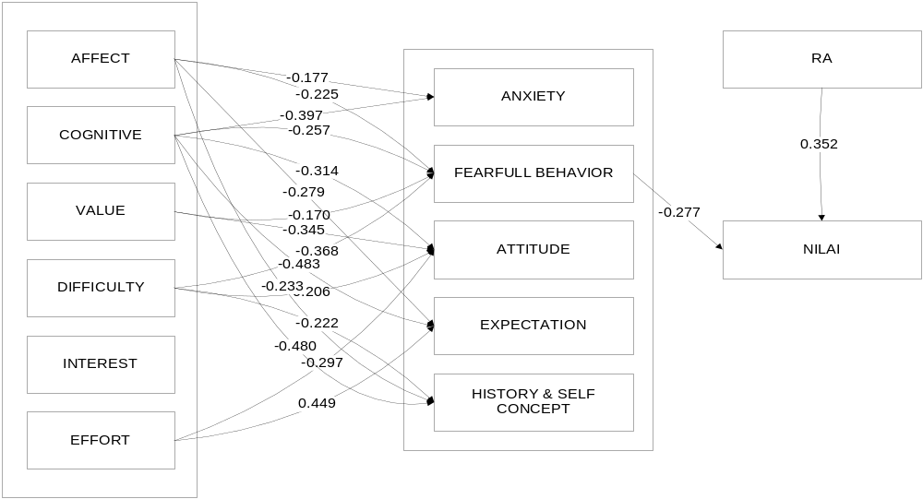
Picture 4. Model of Factors that Influence the Mastery of Statistics Subject on Psychology Students of Universitas Padjadjaran

DISCUSSIONS
From this research, it can be inferred that mathematically thinking skill positively influences the mastery of statistics. It means that the higher the students’ skill to think practically by counting, reasoning and thinking consecutively in making inferences, the higher the statistics score they get, which shows the mastery of statistics. This thing is comprehensible because the materials and the problems in statistics in Psychology Faculty are related to thinking, counting practical-mathematically, and thinking consecutively skills in making inferences.

This research also shows that the hypothesis we have formulated, the aspects of attitude toward statistics influence the aspects of anxiety about statistics. The influence is various, but almost all of them is negative. Only one influences positively, which is the influence of effort aspect of attitude toward statistics, on expectation aspect of anxiety about statistics.

Affect aspect on students regarding statistics, negatively influences anxiety factor, fearful behavior, hopes/demands, history, and self-concept. Which means, the more positive students feel about statistics, the lower students feel anxiety, fear, worry and have hopes/demands concerning statistics. It also means the more positive students feel about statistics, the more positive students’ self esteem concerning statistics.

Cognitive competence aspect on students, negatively influence all anxiety about statistics factors. Which means, the more students judge themselves as knowing and skilled when applying statistics, the lower students feel anxiety, fear, and worry about statistics. This also means the more students judge themselves as knowing and skilled when applying statistics, the more positive attitude they have toward statistics, and the more positive their self-esteem concerning statistics.

Value aspect on students toward statistics; negatively influence fearful behavior factor and students’ attitude toward statistics. This means, the more students judge statistics as useful, relevant, and beneficial for their personal and professional life matters, the lower they feel fear and worry about statistics and the more positive attitude they have toward statistics.

Difficulty aspect on students toward statistics, negatively influences fearful behavior factor, attitude toward statistics, and self-concept concerning statistics. Which means, the more students judge statistics are easy, the lower they feel fear and anxiety concerning statistics, the more positive attitude they have toward statistics, and the more positive self-esteem they have concerning statistics.

Interest aspect on students does not influence anxiety about statistics factors. Which means, the interest level students have on statistics does not influence their anxiety, fear, and worry about statistics, hopes/demands on statistics, and self-esteem they have concerning statistics.

Effort aspect positively influences students’ attitude toward statistics and negatively influences hopes/demands. This means, the more effort the students put to learn statistics, the more positive their attitude toward statistics and the lower their comprehension on demands to mastery statistics.

Anxiety about statistics factor that influences scores that represent the mastery of statistics subject, is only fearful behavior factor. The relation is negative, which means the more the students are scared of statistics teachers, asking for help, and the more worried and tense they are, the lower their scores that represent the mastery of statistics subject.

REFERENCES
Babbie, E.R.(1995).The Practices of Social Research. New York: Wadswort Publishing Company Inc.
Chiesi, F & Primi, C (2009). Cognitive and Non Cognitive Factors Related to Students Statistics Achievement.
Friedenberg, L. (1995). Psychological Testing. Singapore: Allyn and Bacon.
Kaplan, R.M. (2001). Psychological Testing. New York: Brool/Cole Publishing Company.
Kerlinger, F. N. (1995). Asas-asas Penelitian Behavioral, translated by Landung R. Simatupang. Yogyakarta: Gajahmada University Press.
Lee, C., Meletiou-Mavrotheris, M, Wachtel, H. & Zeleke, A. (2002). The Issue of Motivation and Expectation in the Introductory Statistics - Obstacles and Opportunities. South Africa: Proceedings of the Sixth International Conference on Teaching Statistics Durban.
Tamis-LeMonda, C.S. & Cabrera.N. (1999).Perspective on Father Involvement: Research and Policy , Social Policy Report. Society for Research in Child Development, Volume XIII, Number 2. 1-25.
Lovett, C.M. & Greenhouse, JB (2000), Applying Cognitive Theory to Statistics Instruction, The American Statistician, Volume 54, Number 3.
Mendenhall. (1990). Elementary Survey Sampling. California: Duxburry Press.
Schau, Candace (2003). Students’ Attitudes: The “Other” Important Outcome In Statistics Education. 2003 Joint Statistical Meetings - Section on Statistical Education. 3673-3683.
Sekaran, U. (1992). Research Methods for Business, Skill Building Approach. Singapore: John Wiley and Sons, Inc.

